**Answers lab SP3_details_OM_SP3**

**details database**

1. Write a trigger that inserts rows into an audit table after you delete an employee from the details table Note: you will also need to create the audit table.

Test your trigger by deleting an employee from the details table and then select all from the audit table to verify that your trigger fired correctly.

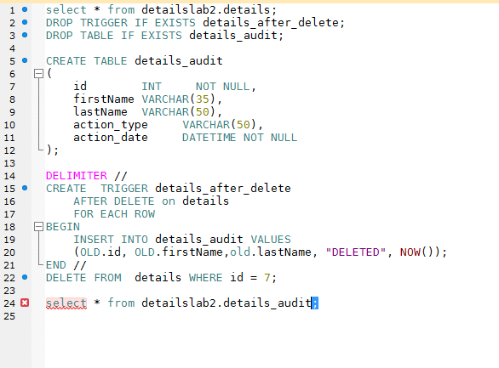

**OM database**

1. Write a BEFORE UPDATE TRIGGER named “CustomerState_before_update” that corrects mixed-case state names in the Customers table

**DELIMITER //**

**CREATE TRIGGER CustomerState_before_update**

**BEFORE UPDATE ON customers**

**FOR EACH ROW**

**BEGIN**

**SET NEW.customer_state = UPPER(NEW.customer_state);**

**END//**

**show triggers;**

**update customers set customer_state = "Ny" where customer_id = 2;**

**select * from om.customers;**